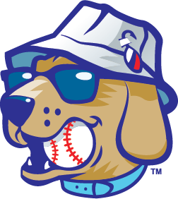

Lake Country DockHounds

Entertainment Internship Description

Position Title: Summer Internship

Season: 2025

The Lake Country DockHounds Baseball Team in Oconomowoc, are a member of the American Association, and seeking an Entertainment intern for the Summer of 2025.

The Lake Country DockHounds will provide an overall learning experience that provides a solid foundation for understanding the business side of professional sports and entertainment. Interns will have the unique opportunity to be a part of the operation of a sports franchise and see firsthand the execution of promotional events in front of a loyal fan base.

The summer internship program runs from approximately Mid-April to Mid-September each year.

*Our motivation and focus is to create lifelong memories: one experience, one fan and one team at a time.*  
  
**Attendance Policy**

The Lake Country DockHounds will strictly enforce an attendance policy for all interns. Full-time paid interns will be expected to work all home games (with some exceptions) and hold the similar office hours and overall time commitment as full-time salaried employees. This also includes events at WBC Park such as concerts, festivals and community appearances. We love to have fun, but please note, there are 50 home games throughout the season and can sometimes be a challenging schedule.

**Compensation**

Full-time paid interns will be compensated $3,000 for the summer.

Duties/Responsibilities

* Work closely with Entertainment & Fan Experience Manager to create a valuable fan experience
* Help in coordination of on-field promotions along with pre and post-game activities
* Develop positive relationships with fans, clients, and community members to help promote the DockHounds
* Work with marketing for special entertainment initiatives including giveaways, theme nights, professional acts, special character appearances, jersey auctions, and live music
* Assist Entertainment & Fan Experience Manager with in-game promotional efforts (on-field, in-between innings, etc.)
* Write and produce in-game content and elements
* Attend mascot/player appearances in the community
* Work with Entertainment & Fan Experience Manager to manage ‘Hounds Promo Crew
* Contribute content to social media accounts while working collaboratively
* Assist with shooting digital photos of fans, on-field promotions, sponsors, events, etc.
* Maintain overall brand integrity in all work
* May help deliver marketing materials in the community and surrounding area.
* Responsibilities will also include assisting other departments when requested or needed

If interested in the position, please email [Tristan@lakecountry-live.com](mailto:Tristan@lakecountry-live.com) to set up an interview.