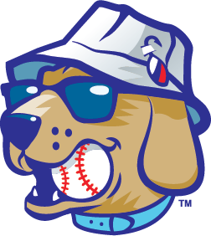  
Community Impact Intern Description

Position Title: Full-Time Summer Internship

Season: 2025

The Lake Country DockHounds Baseball Team in Oconomowoc, are a member of the American Association, and seeking a full-time Community Impact intern for the summer of 2025.

The Lake Country DockHounds will provide an overall learning experience that provides a solid foundation for understanding the business side of professional sports and entertainment. Interns will have the unique opportunity to be a part of the operation of a sports franchise and see firsthand the execution of promotional events in front of a loyal fan base.

By working home games during the 2025 season, interns will have the opportunity to interact with fans and to apply what they have learned in the office to actual game day situations. There will be a heavy emphasis on customer service and providing a safe, fun, affordable and overall enjoyable experience for all fans.

The full-time paid internship program runs from approximately Mid-April to Mid-September each year.

*Our motivation and focus is to create lifelong memories: one experience, one fan and one team at a time.*

**Attendance Policy**

The Lake Country DockHounds will strictly enforce an attendance policy for all interns. Full-time paid interns will be expected to work all home games (with some exceptions) and hold the similar office hours and overall time commitment as full-time salaried employees. This also includes events at WBC Park such as concerts and festivals. We love to have fun, but please note, there are 50 home games throughout the season and can sometimes be a challenging schedule.

**Compensation**

Full-time paid interns will be compensated $3,000 for the summer.

Duties/Responsibilities

* Work closely with Foundation board to fulfill LC DockHounds Foundation initiatives.
* Design and develop marketing strategies and assets for the Foundation and any community impact programs i.e. Food Drive, Blood Drive, Day At the Park programs etc.
* Assist in the set-up development of Non-Profit 50/50 raffle during DockHounds home games.
* Assist with community events and on-field activities.
* Aid in executing and coordinating the Diamond in the Ruff Golf Outing.
* Responsibilities will also include assisting other departments when requested or needed.

If interested in the position, please email [Tristan@lakecountry-live.com](mailto:Tristan@lakecountry-live.com) to set up an interview.