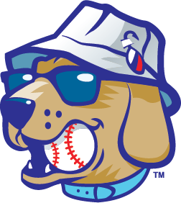

Lake Country DockHounds

Hospitality Intern Description

Position Title: Gameday Summer Internship

Season: 2025

The Lake Country DockHounds Baseball Team in Oconomowoc, are a member of the American Association, and seeking a gameday Hospitality intern for the summer of 2025.

The Lake Country DockHounds will provide an overall learning experience that provides a solid foundation for understanding the business side of professional sports and entertainment. Interns will have the unique opportunity to be a part of the operation of a sports franchise and see firsthand the execution of promotional events in front of a loyal fan base.

By working home games during the 2025 season, interns will have the opportunity to interact with fans and to apply what they have learned in the office to actual game day situations. There will be a heavy emphasis on customer service and providing a safe, fun, affordable and overall enjoyable experience for all fans.

The gameday paid internship program runs from approximately Mid-April to Mid-September each year.

*Our motivation and focus is to create lifelong memories: one experience, one fan and one team at a time.*

**Attendance Policy**

The Lake Country DockHounds will strictly enforce an attendance policy for all interns. Gameday paid interns will be expected to work all home games (with some exceptions). This also includes events at WBC Park such as concerts and festivals. We love to have fun, but please note, there are 50 home games throughout the season, and it can sometimes be a challenging schedule.

**Compensation**

Gameday paid interns will be compensated $1,500 for the summer.

Duties/Responsibilities

* Cooking, prepping, and following recipes.
* Setting up stations along with setting up and breaking down club level.
* Responsible for overseeing the operational aspects of running a food service-related operation.
* Performs tasks related to ensuring compliance with safe food prep and handling, storage and sanitation.
* Provide direct “hands-on” cooking or prep work to deliver quality and prompt service.
* Overseeing all concession stands to endure proper operation.
* Assist in working with vendors, ordering food products and beverages.
* Maintain accurate inventory.
* Help manage concessions staff, including training, delegating responsibilities and developing a fun and productive atmosphere.
* Operational duties such as cleaning and organizing.
* Ensuring an exceptional fan experience through great customer service.
* Responsibilities will also include assisting other departments when requested or needed.
* Must be able to lift 30+ pounds.

If interested in the position, please email [Tristan@lakecountry-live.com](mailto:Tristan@lakecountry-live.com) to set up an interview.